Sam McDowell

7/10/2020

Lab 4-1.3

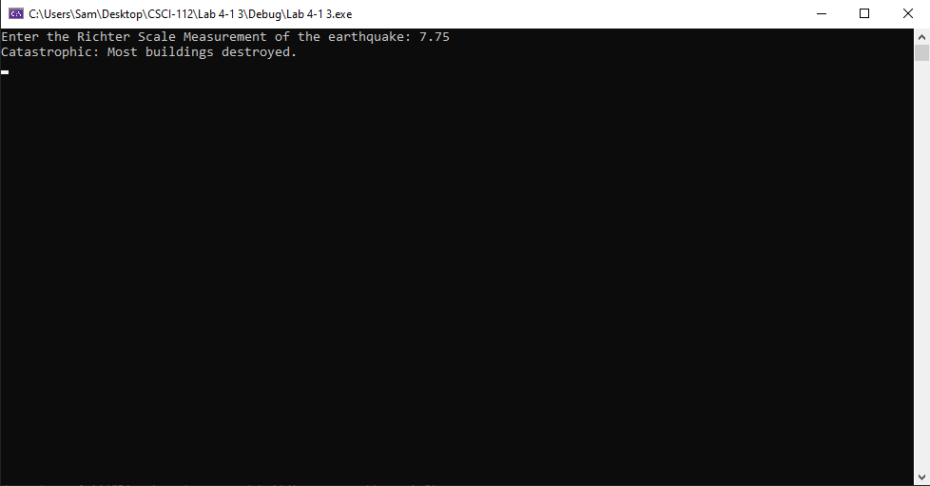

# Transcription:

Enter the Richter Scale Measurement of the earthquake: 7.75

Catastrophic: Most buildings destroyed.